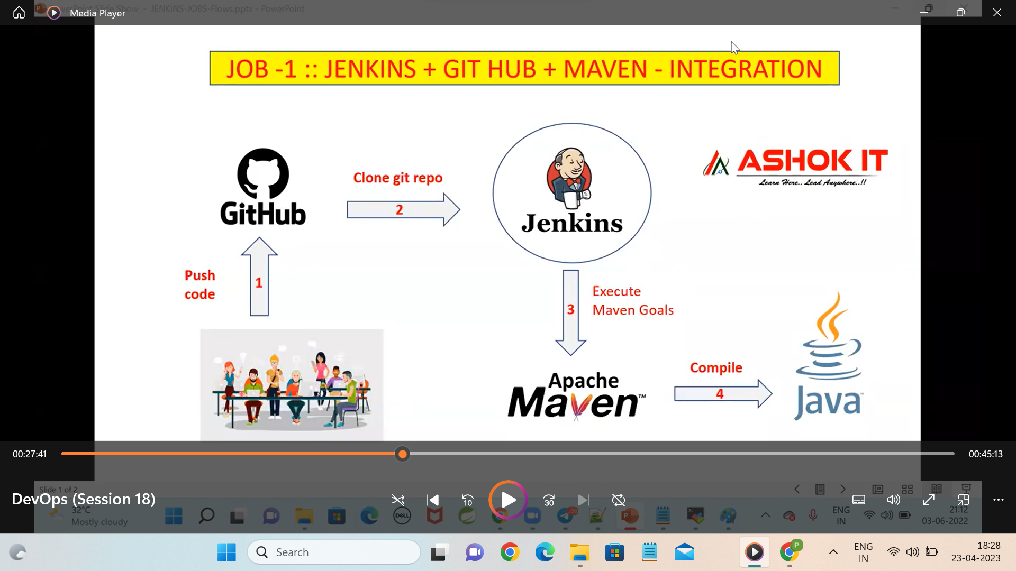

This is the first job creation in the Jenkins.

In the above diagram we will use four softwares

1)git – we will in install in the aws vm

2)Jenkins – we will install in the aws vm

3)maven- we will install the maven in the Jenkins

4)java -we will install the java in the Jenkins

Last two we are installed in the Jenkins because of the version problem

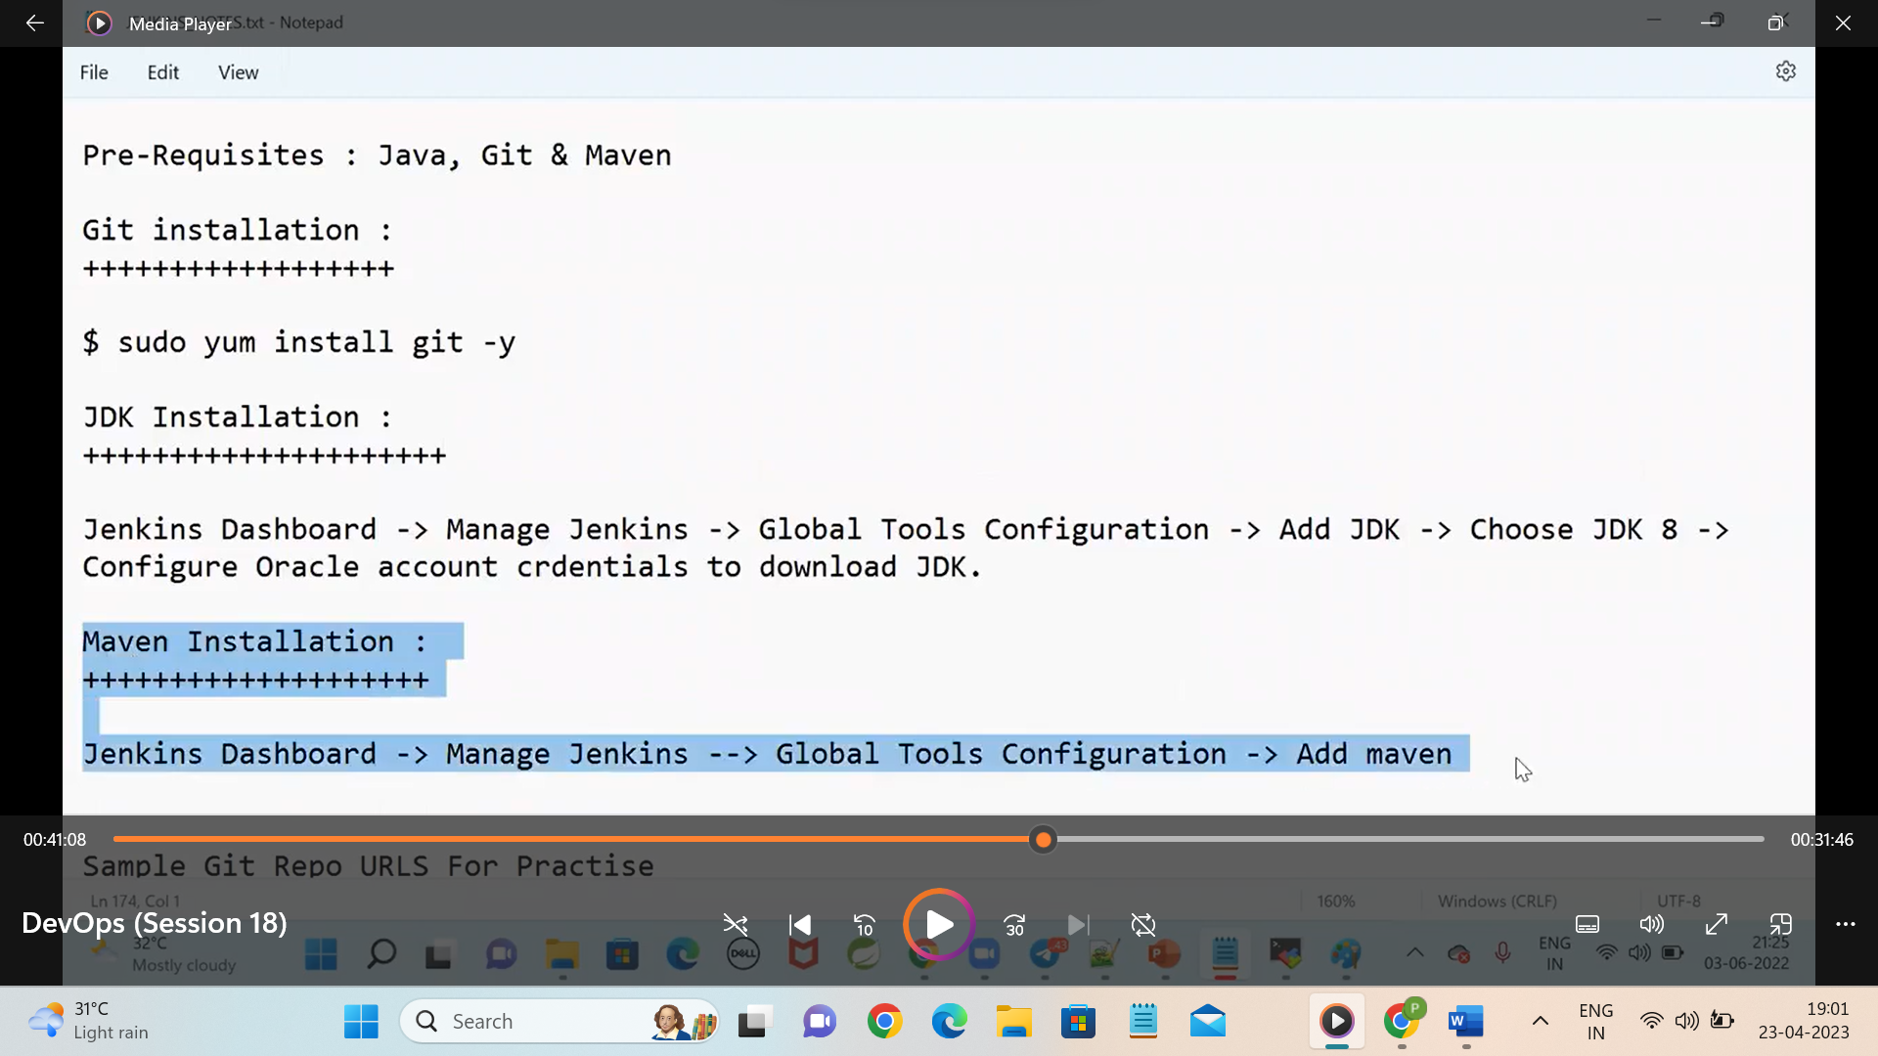

The above will be integrated in vm and Jenkins

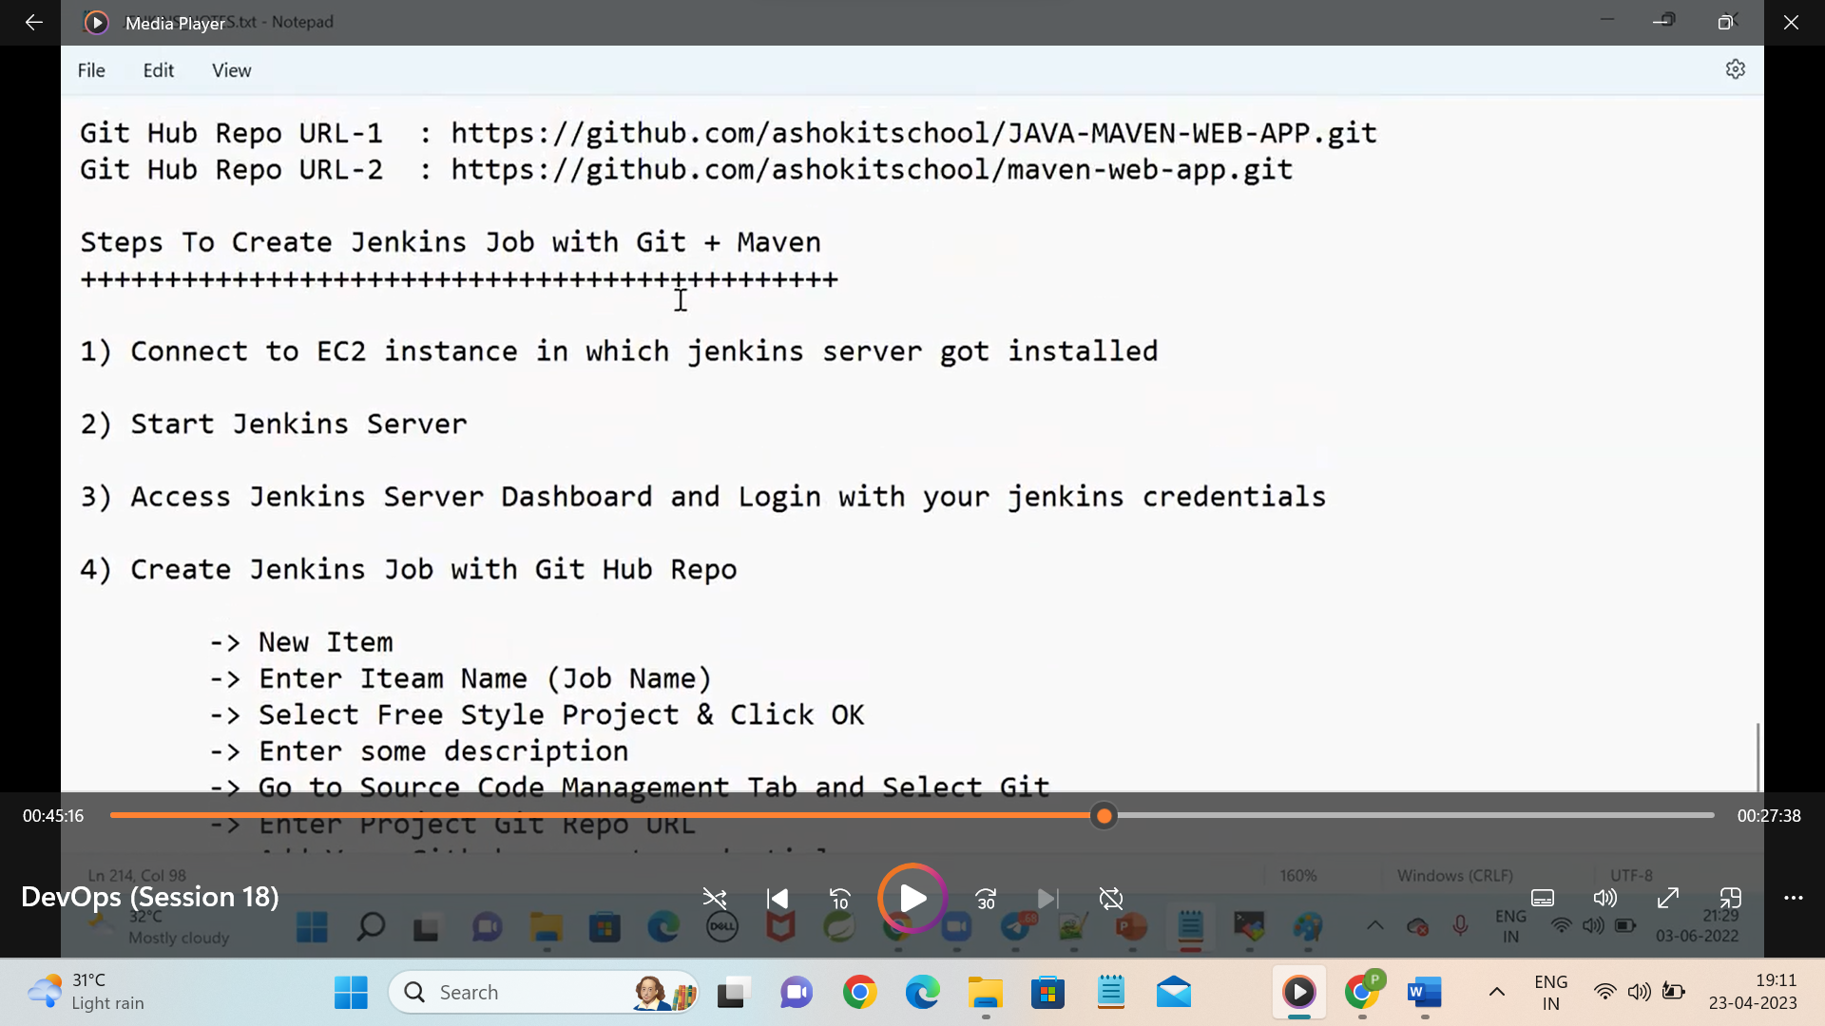

Take the github url and do as follows

